COUNCIL ON AGING
Town Of Needham



HOW TO?

- This transportation service requires advance notice in order to schedule a ride.
- Requests for a ride on the van should be made with at least 24 hours notice minimum
- Please be kind and call to cancel a requested ride.
- The driver will call on their way. Please wait for the call before going outside. All riders should wait inside until the van arrives for pick up.

Wheelchair passengers must be able to approach the van and once disembarked get to final destination on own.

- All riders are required to have a phone and a working number with which to communicate.
- Seatbelts must be properly worn at all times, including during parking operations.
FEE per ride $1, $2 round trip

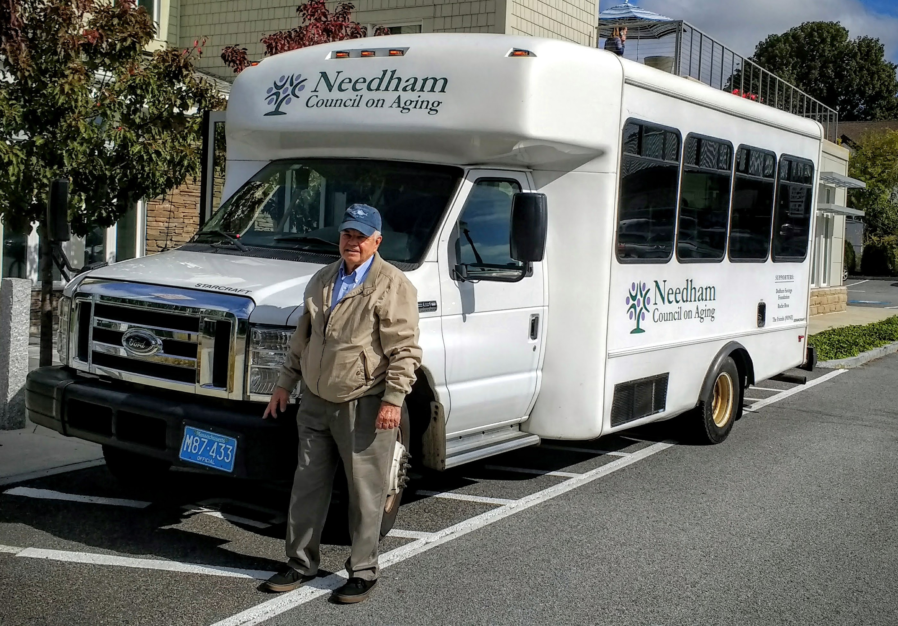

Needham Council on Aging
300 Hillside Avenue, Needham, MA 02494
TEL: 781-455-7555 www.needham.gov/coa

RIDERS MUST WEAR A MASK AT ALL TIME OVER MOUTH AND NOSE
Due to ever changing COVID-19 UPDATES, please call the transportation coordinator for any questions.

TRANSPORTATION SERVICE

Needham Council on Aging (NCOA) provides rides to and from a Needham resident's home to the Senior Center, and from his or her home to selected shopping locations.

A request for a ride on the van requires
24 hrs notice minimum.

COA Transportation is partially funded by the Town.
FEE per ride $1, $2 round trip

All riders are required to have a phone and a working number with which to communicate.

TRANSPORTATION COORDINATOR
781-455-7555 X204
www.needham.gov/coa

UNAVAILABLE
UNAVAILABLE
UNAVAILABLE
UNAVAILABLE
UNAVAILABLE
PLEASE TAKE NOTE:

- All changes to scheduled rides, ride requests, and cancellations must be called into 781-455-7555 ext. 204 at least 24 hrs. in advance.
- Please do not leave a message at the Front Desk: always contact the transportation office directly.
- If the Transportation Coordinator is unavailable during regular hours of operation, listen to the outgoing message and follow the instructions.
- Reservations must be made 24 hrs. in advance minimum. Under 24 hrs. riders will be placed on stand-by or waiting list. Rides are provided on a first come first served basis. Calls or voicemail received after 3pm will be treated as “Next Day”. Sorry, we cannot accept same day requests.
- Seatbelts must be worn and properly fastened at all times, including during parking operations.
- Transportation requests or changes can only be made through the Transportation Coordinator. Please leave a voice message if the Transportation Coordinator is unavailable. Phone: 781-455-7555 ext. 204
- Please do NOT call the driver directly, always call the transportation office
- All groceries will be carried to the residence entrance only. Please limit the number of shopping bags to 4 bags or 20lbs of groceries, whichever comes first. If you need more than 20 lbs, you will need to carry your own groceries or reserve a second trip at a different date.
- All your rides and grocery shopping trips can be organized on a daily, weekly, monthly or yearly basis

Sorry, we cannot provide medical transportation to and from hospital or doctor’s appointments. Please call the COA Social Services for more information or other solutions. 781-455-7555 X205 or X212

Supermarket Schedule

Tuesday | Roche Bros.  10:00 – 11:00 a.m. | Sudbury Farms  1:00 – 2:00 p.m.
Wednesday | Sudbury Farms  10:00 – 11:00 a.m. | Sudbury Farms  1:30 – 2:30 p.m.
Thursday | Sudbury Farms  10:00 – 11:00 a.m. | Sudbury Farms  1:00 – 2:00 p.m.

twowednesday per month we organize shopping trips to Out-Of-Town to Market Basket whaltham
We organize trips to pharmacies, banks, Roche Bros. Sudbury Farms, Trader’s Joe and more.
Please see the Senior Compass for more information and date.

Due to ever changing COVID-19 UPDATES, please call the transportation coordinator for any questions.

TRANSPORTATION COORDINATOR
781-455-7555 X204

Ride the COA Van from Home
to the Senior Center to :

- Participate in events, programs, movies and activities.
- Enjoy a breakfast or a hot lunch.
- Trips to Grocery Shopping, Pharmacy, Banks
This valuable service is funded primarily through donations. Your $1.00 donation per ride is essential

