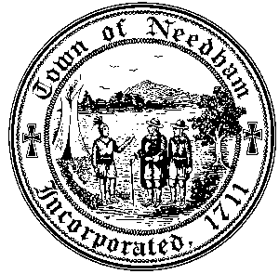
PLANNING & COMMUNITY DEVELOPMENT

Large House Review Committee Working Group Meeting

Tuesday April 1, 2025
4:30 p.m.

Charles River Room, Public Services Administration Building
500 Dedham Avenue, Needham, Massachusetts

- Discussion of other possible research the working group could perform to assist the Large House Review Committee.

